关于CTR
CTR专注于研究瞬息变幻的中国市场，服务聚焦品牌广告传播、媒介经营管理和消费者洞察三大领域，层层透析品牌营销传播全过程。作为挖掘数据的专家，我们从海量数据信息中分析、解读和预测市场发展和消费者行为及态度的变化，并凭借国际化的视野、丰富的实战经验和睿智的专家团队，洞悉大数据时代的挑战，挖掘数字背后的潜力，洞察趋势外无限的商机，激发决策灵感！这就是洞察的力量，我们之所以能这样做，是因为我们更懂中国。

洞察中国是CTR品牌的核心价值，旨在分享观点、洞悉趋势、展望未来。帮助企业、品牌了解中国市场和中国消费者，助力企业和品牌赢在中国！

更多详情请访问：www.ctrchina.cn 或扫描下方二维码：
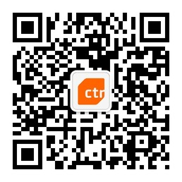
微信号：CTR洞察中国

CTR analysts and experts help advertisers, media owners and advertising agencies to measure their media image and impact. Born and raised in China, Chinese culture and values are a part of our DNA. We have witnessed the seismic transformation of the market, experienced numerous industry reforms, whilst building expertise in media management, brand & advertising communications and consumer research. Our in-depth knowledge of the local market with a global perspective enables us to discover the insights that make sense of what is hidden beneath today’s developments. We inspire our clients to make informed decisions based on our unparalleled and profound understanding of the critical challenges they face in the Chinese marketplace. This is what we bring you, China insights. We can do this because we know China better.
CHINA INSIGHT is at the core of our brand value. We aim to share unique viewpoints, look behind the numbers, beyond the trends and between the lines. In short, our job is to help companies and brands understand the Chinese market, its people, and to win in China!
For further information, please visit www.ctrchina.cn

